Ideation Phase
Brainstorm & Idea Prioritization Template

Date | 25 October 2026
Team ID
Project Name | StaffSync
Maximum Marks | 4 Marks

Brainstorm & Idea Prioritization Template:
Brainstorming provides a free and open environment that encourages everyone within a team to participate in the creative thinking process that leads to problem solving. Prioritizing volume over value, out-of-the-box ideas are welcome and built upon, and all participants are encouraged to collaborate, helping each other develop a rich amount of creative solutions.
Use this template in your own brainstorming sessions so your team can unleash their imagination and start shaping concepts even if you're not sitting in the same room.
Reference: https://www.mural.co/templates/brainstorm-and-idea-prioritization
Step-1: Team Gathering, Collaboration and Select the Problem Statement
- Core Issue Identified: Fragmented human resource operations, manual attendance check-ins, delayed leave approval pipelines, and lack of centralized company announcements.
- Target Beneficiaries: Employees seeking self-service transparency, Managers streamlining team leave/attendance, and HR personnel managing enterprise-wide workflows.
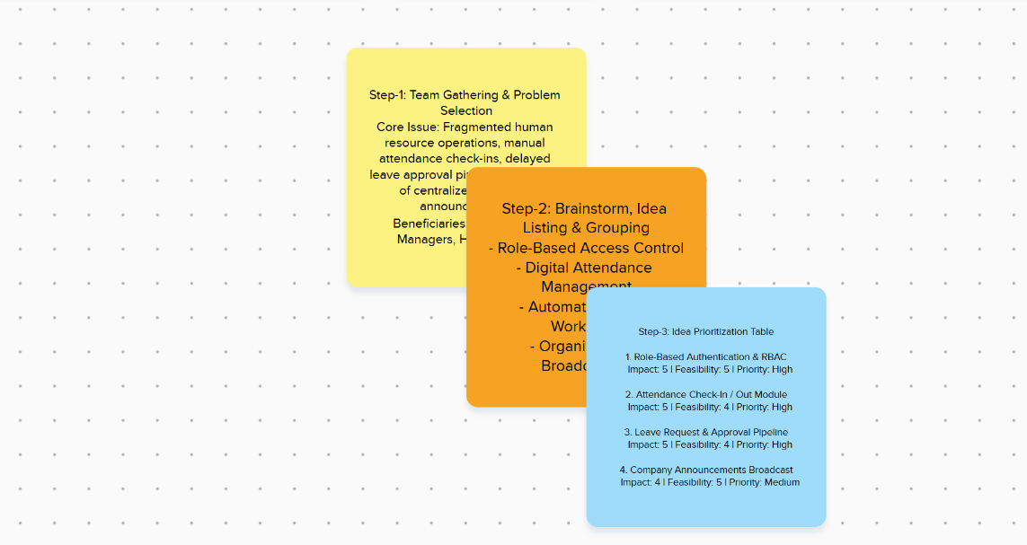

Step-2: Brainstorm, Idea Listing and Grouping
- Role-Based Access Control (RBAC): Secure login sessions providing tailored dashboard views for Employees, Managers, and HR/Admins.
- Digital Attendance Management: Real-time check-in and check-out tracking to replace traditional paper/manual logs.
- Automated Leave Workflows: Streamlined submission, review, and approval/rejection pipelines for various leave types.
- Organizational Broadcasting: Centralized real-time notification system for company-wide updates and announcements.

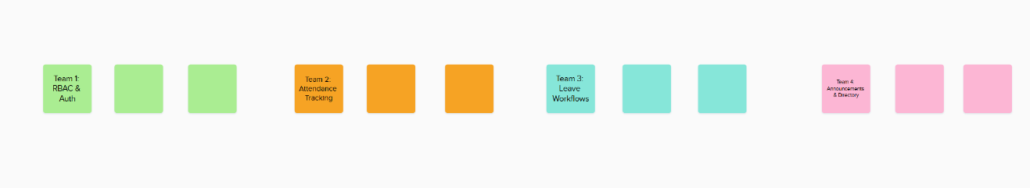
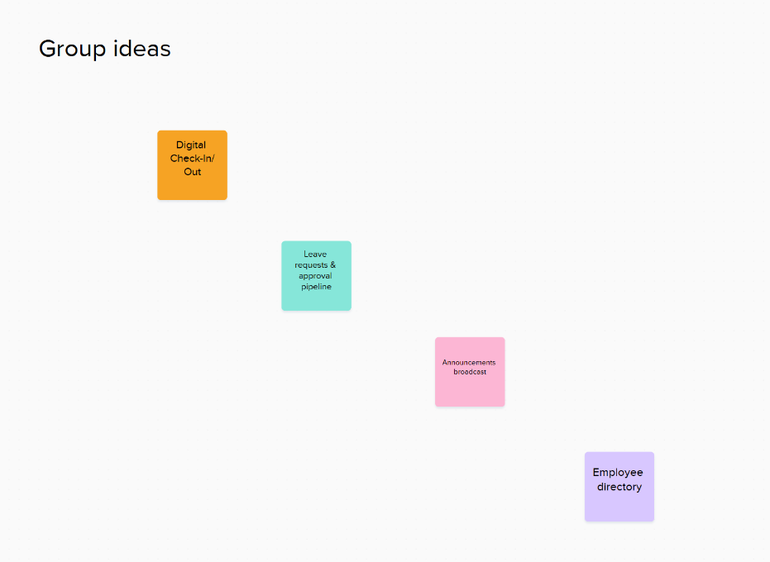

Step-3: Idea Prioritization

Idea / Module | Impact (1-5) | Feasibility (1-5) | Priority Score
Role-Based Authentication & RBAC | 5 | 5 | High (Must Have)
Attendance Check-In / Out Module | 5 | 4 | High (Must Have)
Leave Request & Approval Pipeline | 5 | 4 | High (Must Have)
Company Announcements Broadcast | 4 | 5 | Medium(Should Have)

